**Project 7**

**How to download and run project from GITHUB**

**Repositories: simple-reactjs-app**

Steps:

1. Go to your GitHub account, click on your profile or in search bar type simple-reactjs-app. It shows various author created the simple reactjs app.
2. Select any one author or publisher and click on fork and click on create new fork. The fork is created.

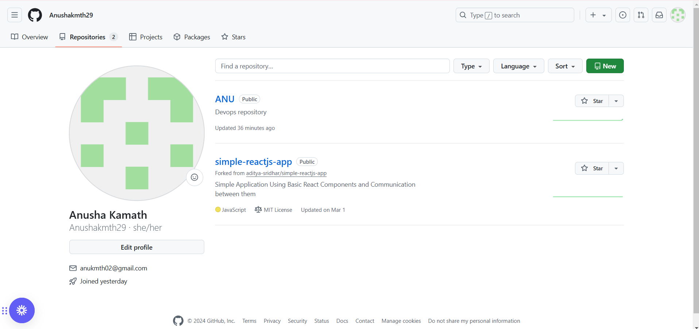

**Clone url:**

1. Go to your repositories and click on simple-reactjs-app and click on code.
2. Click on download sip. Your sip file is downloaded and right click on it. Click on extract all.

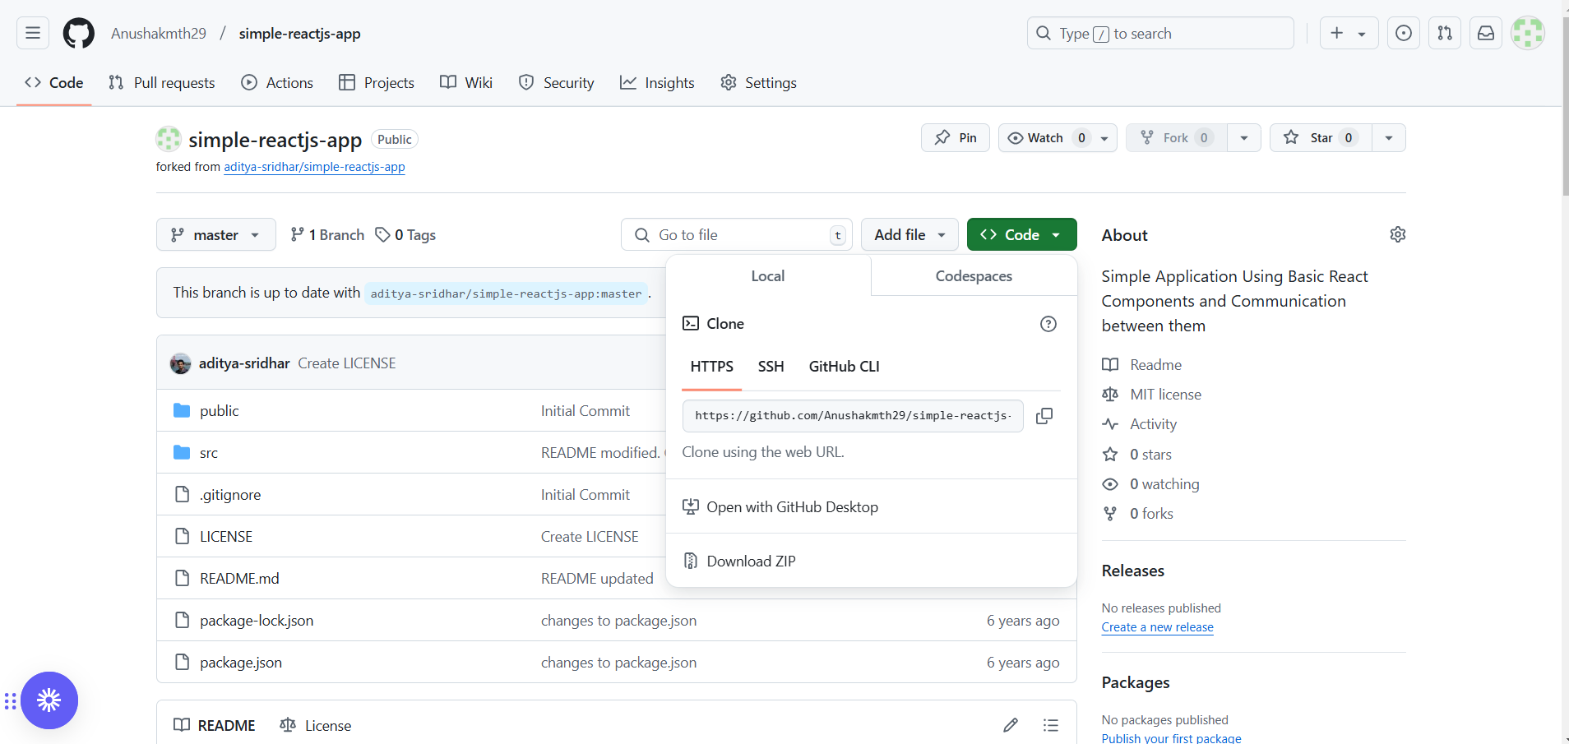

**Command prompt: cloning the simple nodejs app**

1. Create new folder as clone and inside that folder, give right click and click on git bash here.
2. Follow the following command: type git clone (paste the url from repository as above) and click enter.
3. Inside the clone folder, the simple-nodejs-app will be cloned. Click on simple-nodejs-app folder and inside that give right click and select git bash here.
4. Git bash get opened and give command as npm install after that npm start.
5. Go to browser, the result is shown.

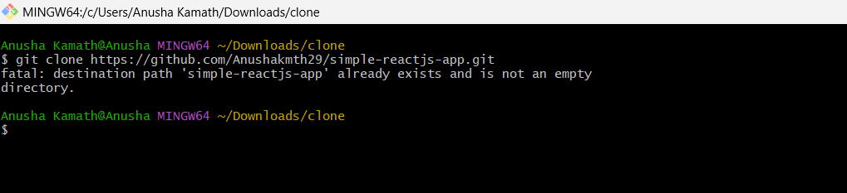

**Cloned simple-reactjs-app:**

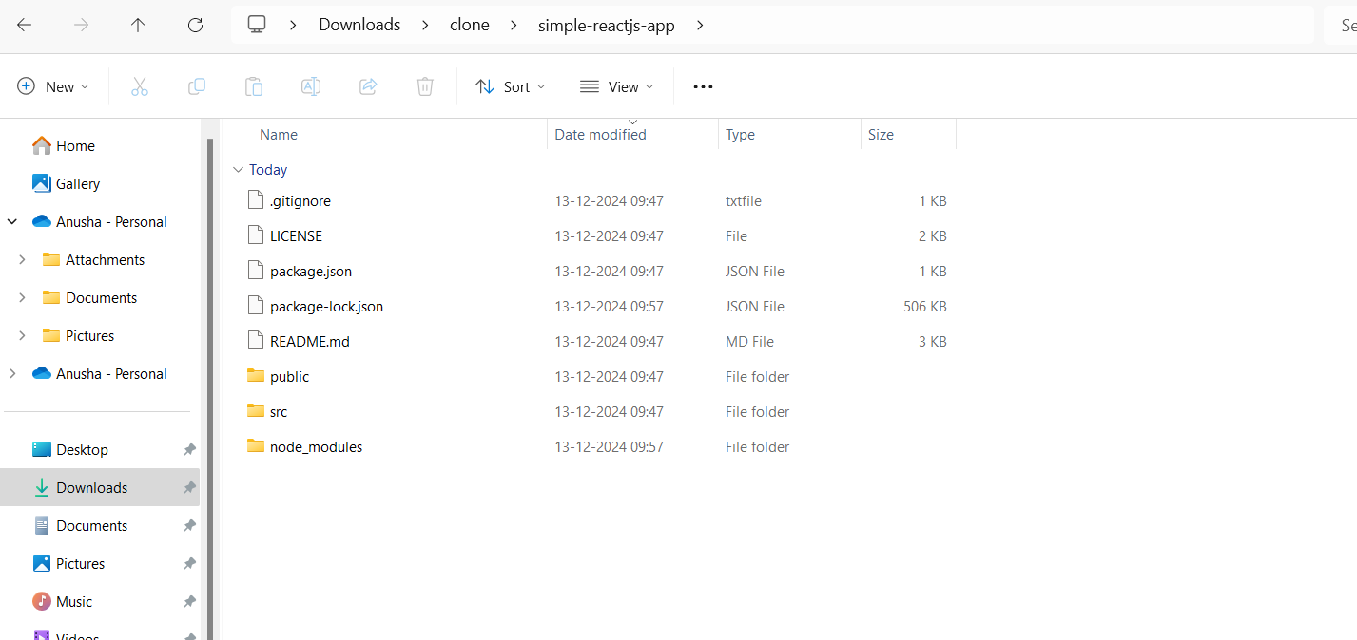

**Command prompt:**

Steps: follow the command in below screenshots

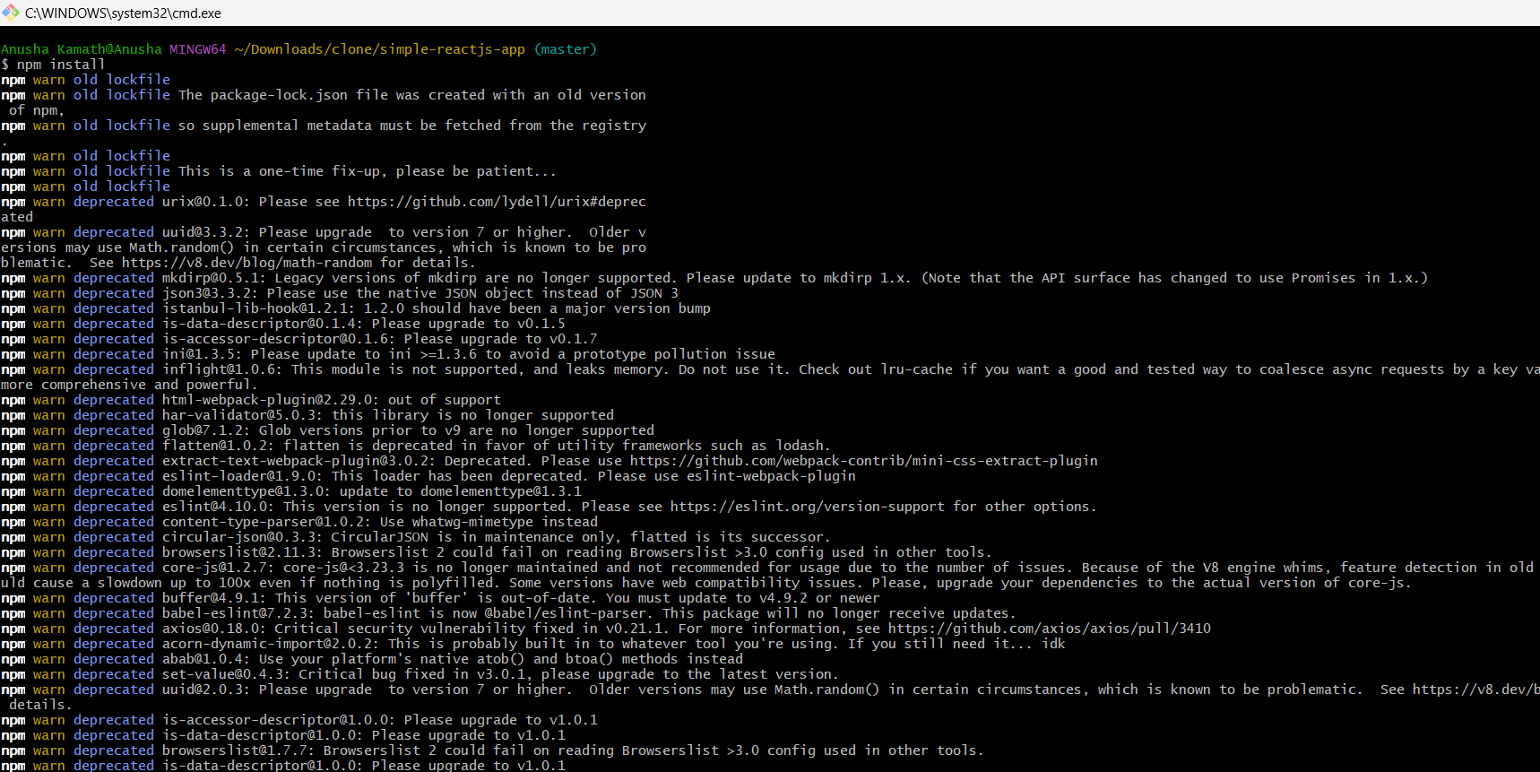

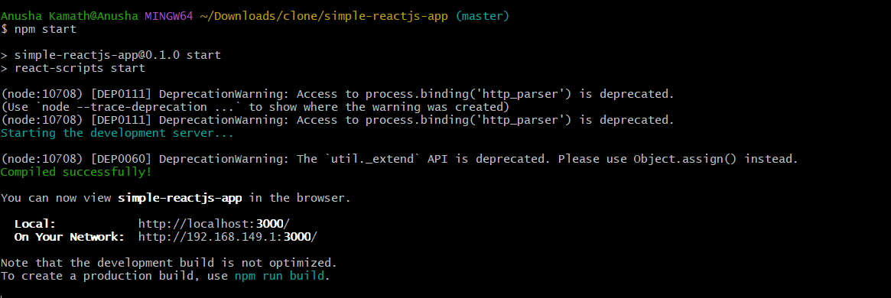

**Final result:**

